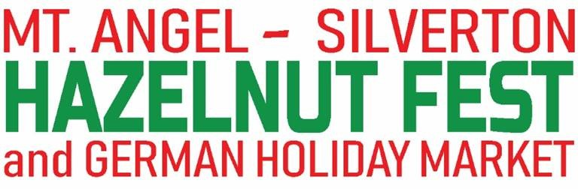
Co-Hosted by the Mount Angel Chamber of Commerce and the Silverton Chamber of Commerce
December, 6 Friday Night Market 4pm to 8pm, Saturday, December 7, 2018, 9am to 5pm and
Sunday, December 8, 2019, 10am to 4pm

BOOTH FEE: $200.00 if application is received by April 1, 2019, $225.00 if application is received after April 1, 2019.
Enclose check for the correct amount. Please note that these are prices for 10’X 10’ space. Please provide a pop-up tent frame without the top canvas and wrap upper frame in white lights.
For more information, contact Mary Grant at 503-932-5279, 503-845-6222 or mary@glockenspielrestaurant.net

BOOTH INFO
Business/Organization Name: _____________________________(Vendor)Website:___________________________
Address: _________________________ City: ___________________State: ________________Zip: ____________
Contact Person:____________________ _Cell: __________________Email:________________________
List all products and provide a full description ____________________________________________________________
Are there special needs such as electrical connections, etc. __________________________________________________
Do you want to participate in the children's cookie crawl? Check here: Yes No____
Do you need a special license or insurance to sell your products such as OLCC__ _Health Department ____
- Set up begins Friday, December 6, starting at 8am over at 3:30pm must be open by 4pm for our Friday night Market
- Food Vendors will be provided space for cooking and must adhere to all Marion County Health laws; licensing, food handling, hand washing, etc.
- All participants agree to leave their areas clean when the festival is over. Garbage cans are provided.
- Break down begins Sunday evening at 4 pm, no sooner please. No animals will be allowed.
- Help us promote this event. Share the information with your customers. Send us a copy of your promotions.
- We will communicate with you via Email
- NO PETS ALLOWED Service Animals specifically trained to aid a disabled person are allowed to enter.
INSURANCE: must be provided
Vendor agrees to procure and maintain comprehensive general liability insurance in the amount of not less than $1,000, 000 per occurrence for at least the length of this event. Please mail a certificate showing proof of this with your application.
WAIVER AND RELEASE FORM
As consideration for my participation in this event, I, on behalf of myself, my heirs, assigns and next of kin, and/or I, as authorized representative of the above business entity, HEREBY WAIVE AND RELEASE, indemnify, hold harmless and forever discharge, Mt. Angel Oregon Hazelnut Festival, Mt. Angel Chamber of Commerce, and its agents, employees, officers, directors, affiliates, successors, volunteers and assigns (hereinafter, the “Released Parties”), of and from any and all claims, demands, debts, contracts, expenses, causes of action, lawsuits, damages and liabilities, of every kind and nature, whether known or unknown, in law or equity, that I ever had or may have, arising from or in any way related to my participation in the Mt. Angel, OR Hazelnut Fest. By this WAIVER AND RELEASE, I assume any risk, and take full responsibility and waive any claims of personal injury, death or damage to personal property, with respect to the Released Parties, in connection with the Mt. Angel, OR Hazelnut Fest. I have read, understand and fully agree to the terms of this WAIVER AND RELEASE. I hereby certify that I am 18 years of age or older, mentally competent to enter into this WAIVER AND RELEASE, and have read the above carefully before signing.
Signature:____________________________________________________ Date: ___________________

Sign and Return this form with your check by July 1, 2019
Mt. Angel and Silverton Hazelnut Festival, Mt. Angel Chamber of Commerce,PO Box 221, Mount Angel, OR 97362

